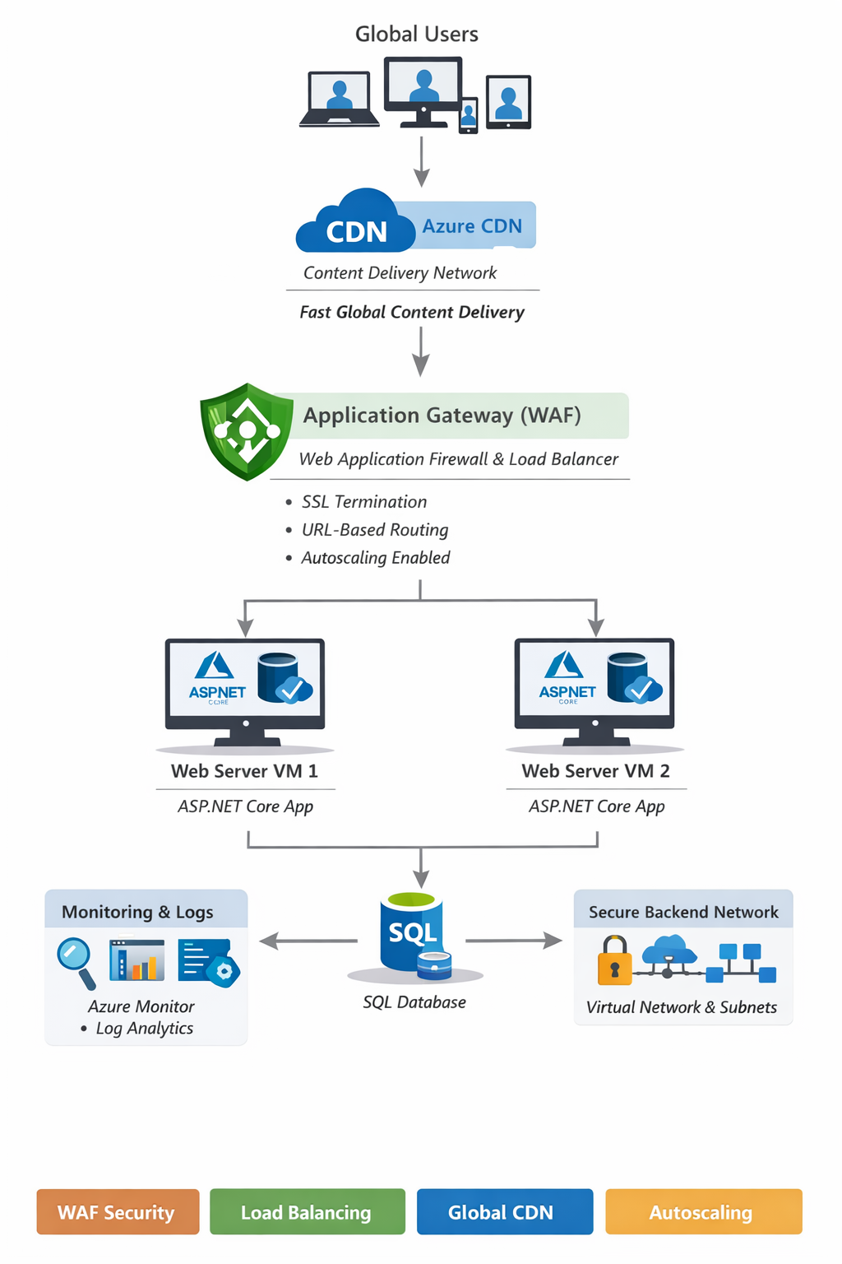

1. Azure Application Gateway

What is it?
Azure Application Gateway is a Layer 7 (HTTP/HTTPS) load balancer.
It routes traffic based on:
- URL (example.com/api vs example.com/images)
- Hostname
- Headers

Real-life Example
One website → multiple backend services
User → Application Gateway → Routes to:
/api → API Server
/images → Image Server

Key Features
- Web Application Firewall (WAF)
- SSL termination
- URL-based routing
- Autoscaling
- Zone redundancy

2. Create Application Gateway (Portal Steps)

Step-by-Step
- Go to Azure Portal → Search Application Gateway
- Click Create

Basics Tab:
- Resource Group: rg-appgw-demo
- Name: appgw-demo
- Region: Central India
- Tier: Standard V2 / WAF V2 (recommended)

Frontend:
- Public IP → Create new

Backend Pool:
- Add backend targets:
  - VM IP / App Service

Routing Rule:
- Listener → HTTP (port 80)
- Backend target → your backend pool

Review + Create
Your gateway is ready

3. Support High Traffic Volumes

How it handles high traffic?
- Load balances across multiple servers
- Uses autoscaling (V2 SKU)
- Health probes remove unhealthy servers

Example
1000 users → Gateway → 5 backend servers
Traffic distributed evenly

4. Autoscaling & Zone Redundancy

Autoscaling
- Automatically increases instances during high traffic
- No manual scaling needed
Configure:
- Min instances: 1
- Max instances: 10+

Zone Redundancy
- Deploy across multiple availability zones
- Protects from data center failure
Enable during creation:
- Select Availability Zones (1,2,3)

5. Azure CDN

What is it?
Azure Content Delivery Network is used to deliver content faster globally.

Example
Without CDN:
User (India) → Server (USA) → Slow
With CDN:
User → Nearby CDN Edge → Fast

What it caches:
- Images
- CSS/JS
- Videos
- Static files

6. Create Azure CDN Profile & Endpoint

Step-by-Step

Step 1: Create CDN Profile
- Search CDN
- Click Create Profile
- Fill:
  - Name: cdn-demo
  - Pricing tier: Standard Microsoft/Akamai

Step 2: Create Endpoint
- Inside CDN Profile → Click + Endpoint
- Fill:
  - Name: cdnendpointdemo
  - Origin type: Storage / Web App
  - Origin hostname: (your app URL)
Endpoint URL:
https://cdnendpointdemo.azureedge.net

7. Monitor Health of Azure CDN

Tools Available

1. Metrics
- Requests count
- Latency
- Cache hit ratio

2. Diagnostic Logs
Enable logs:
- Go to CDN Profile
- Click Diagnostic settings
- Send logs to:
  - Log Analytics
  - Storage account

3. Alerts
- Create alerts on:
  - High latency
  - Errors

8. Azure Diagnostic Logs

What are they?
Logs that track:
- Requests
- Errors
- Performance

Enable Diagnostic Logs
- Go to resource (App Gateway/CDN)
- Click Diagnostic Settings
- Click + Add
- Select:
  - Access logs
  - Performance logs
- Send to:
  - Log Analytics Workspace

Query Example (Log Analytics)
AzureDiagnostics
| where ResourceType == "APPLICATIONGATEWAYS"
| project TimeGenerated, clientIP_s, requestUri_s

9. Azure CDN Usage Patterns

What is it?
Analyzing how users access your content.

Key Metrics
Metric | Meaning
Cache Hit Ratio | % served from CDN
Bandwidth | Data usage
Requests | Total hits
Latency | Response time

Common Patterns

1. High Cache Hit Ratio ✅
Good performance

2. Low Cache Hit Ratio ❌
CDN not caching properly

3. Traffic Spikes
Use autoscaling + CDN

Full Architecture (Real Project)
User → CDN → Application Gateway → Backend VMs
↓
Load Balancing + Security

When to Use What?
Service | Use Case
Application Gateway | Routing + Load balancing
CDN | Fast content delivery
Diagnostic Logs | Monitoring & debugging

Interview Summary
Application Gateway
Layer 7 load balancer with routing + WAF
Autoscaling
Automatically adjusts instances based on traffic
CDN
Delivers content globally with low latency
Diagnostic Logs
Helps monitor and troubleshoot Azure resources

Project
This project is a real-world, production-style Azure architecture using:
- Application Gateway (WAF + Load Balancer)
- Azure CDN (global performance)
- Virtual Machines (host app)
- ASP.NET Core Web App
- Monitoring + Security
This is interview-ready + industry-level architecture 🔥

Project: Scalable Secure Web App using CDN + App Gateway + VM

Architecture Diagram
🌍 Global Users
│
▼
┌────────────────────────────┐
│ Azure CDN │
│ (Cache + Fast Delivery) │
└────────────┬──────────────┘
│
▼
┌────────────────────────────┐
│ Application Gateway │
│ (WAF + Routing + SSL) │
└────────────┬──────────────┘
│
┌────────────┴────────────┐
▼ ▼
┌───────────────┐ ┌───────────────┐
│ VM 1 │ │ VM 2 │
│ ASP.NET App │ │ ASP.NET App │
└───────────────┘ └───────────────┘
│ │
└──────────┬────────────┘
▼
(Optional Database)

Business Scenario
An e-commerce company wants:
- Fast global access → CDN
- Secure entry point → Application Gateway (WAF)
- Load balancing → multiple VMs
- High availability → autoscaling

STEP-BY-STEP IMPLEMENTATION

STEP 1: Create Resource Group
az group create --name rg-enterprise-app --location centralindia

STEP 2: Create Virtual Network

Azure Portal:
- Go to Virtual Network
- Create:
  - Name: vnet-app
  - Address space: 10.0.0.0/16

Add Subnets:
- subnet-app → for VMs
- subnet-gateway → for App Gateway

STEP 3: Create Virtual Machines (2 instances)
- Go to Virtual Machines → Create
- Configure:
  - Name: vm-app-1, vm-app-2
  - Image: Windows Server / Ubuntu
  - Size: B1s
  - Network: subnet-app

STEP 4: Install ASP.NET Core App on VM

Option A: Quick Test App
On VM:
dotnet new webapp -o MyApp
cd MyApp
dotnet run --urls=http://0.0.0.0:5000
Open port 5000 in NSG

STEP 5: Create Application Gateway
- Search Application Gateway
- Click Create

Configuration:
- Tier: WAF V2
- VNet: vnet-app
- Subnet: subnet-gateway

Backend Pool:
- Add:
  - VM1 private IP
  - VM2 private IP

Health Probe:
- Protocol: HTTP
- Path: /

Listener:
- Frontend port: 80

Routing Rule:
- Route traffic → backend pool
Now traffic is load balanced

STEP 6: Enable WAF (Security)
- Go to App Gateway → Web Application Firewall
- Mode: Prevention
- Rule set: OWASP
Protects against:
- SQL Injection
- XSS attacks

STEP 7: Enable Autoscaling
- App Gateway → Settings → Autoscale
- Set:
  - Min: 1
  - Max: 5+

STEP 8: Create Azure CDN

Create Profile
- Search CDN → Create
- Name: cdn-enterprise
- Pricing: Standard Microsoft

Create Endpoint
- Add Endpoint:
  - Origin: Application Gateway Public IP
Now traffic flows:
User → CDN → App Gateway → VM

STEP 9: Enable Diagnostic Logs

For Application Gateway
- Go to App Gateway
- Diagnostic Settings → Add
- Enable:
  - Access logs
  - Performance logs

For CDN
- Go to CDN Profile
- Enable logs → Send to Log Analytics

STEP 10: Monitor Using Log Analytics

Sample Query:
AzureDiagnostics
| where ResourceType == "APPLICATIONGATEWAYS"
| summarize count() by clientIP_s

Security Enhancements
- Use HTTPS (SSL certificate)
- Add Key Vault for secrets
- Restrict NSG rules
- Use Private IP for backend

Performance Enhancements
- CDN caching rules
- Compression (gzip)
- Autoscaling VMs (VM Scale Set - advanced)

Final Project Structure
EnterpriseApp/
│
├── ARM/
│ ├── appgateway.json
│ ├── vm.json
│
├── WebApp/
│ └── ASP.NET Core App
│
├── Docs/
│ └── architecture.md

Interview Explanation (Very Important)
How system works:
“User request first goes to CDN for fast delivery. Then Application Gateway provides security and routing. Traffic is load balanced across multiple VMs hosting ASP.NET Core application.”

